
INN374 Assignment 2
Service-Oriented Architecture for Automotive Maintenance Activities


Student Number | Student Name
N8911371 | Chen-I Fang (Lester)
N9244255 | Manuel Brauer
N8964955 | Zahran AlAbri

Description of Automotive Maintenance Activities Service
Scope and basic functionality.

- Client application supports a GUI for customer requesting maintenance. It is written in Java using Swing and connects to the Sales Service.
- Sale Service is a SOAP web service provides methods for communication with customers and access the following web services. It is written in Java.
- Warehouse Service is a web service provides 8 methods to access the Warehouse Database server
- Supplier Service is a web service provides 6 methods to access the Supplier Database server
- Insurance Service is a web service provides the Sale service with the required details about a customer (implemented using WSDL)
- Garage Service is a web service provides the client with the appointment date after receiving a request from Sale service (implemented using WSDL)

Web-based Service Repository

Index HTML for all services
http://fastapps04.qut.edu.au/n8911371/index.html

Sale Service:
http://fastws.qut.edu.au/

Warehouse Service:
http://fastapps04.qut.edu.au/n8911371/WebService/n8911371WarehouseService/WarehouseService.html

Supplier Service: http://fastapps04.qut.edu.au/n8911371/WebService/n8911371SupplierService/SupplierService.html

Insurance Service:
http://fastapps04.qut.edu.au/n8964955/n8964955_InsuranceWS.html

Garage Service:
http://fastapps04.qut.edu.au/n8964955/n8964955-GarageWS.html

Logical Layered Architecture
Public Service: Client
Process Centric Service : Insurance, Sales, Garage and Supplier
Basic Process (logic-centric) : Garage
Basic Process (data) : Warehouse

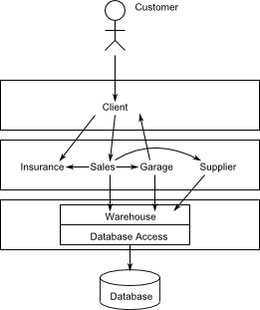

Level 1 Interaction Diagram
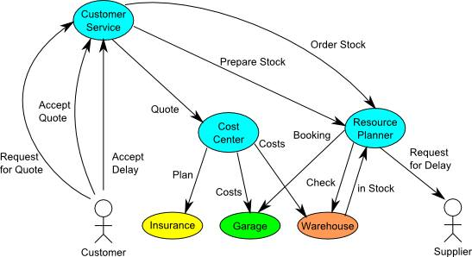

Choreography model

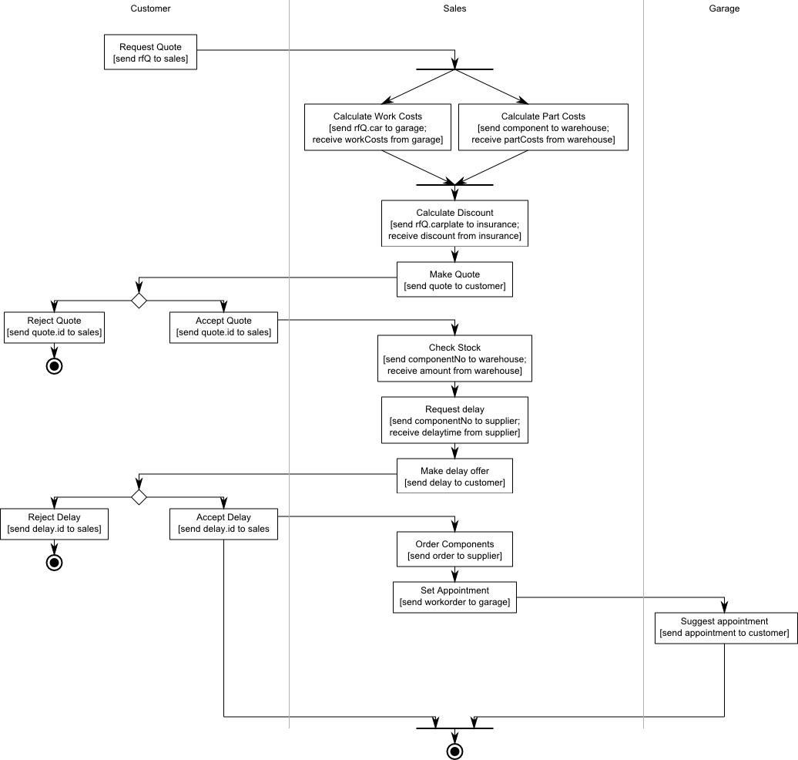
Orchestration model for process-centric service
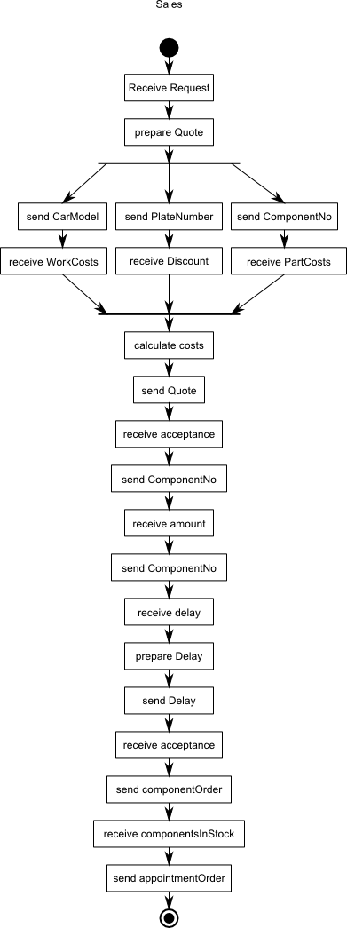
SOA analysis and design methodology

For Servicing Our Autos,

- Top-down approach to service analysis
- the state is relatively stable, not often changeable
- Scenario is followed the step : what -> who -> why and how

- Not –bottom up approach
- Preferred with using legacy systems
- No legacy systems in this project

Assumption
Supplier
- We just consider only one supplier Database

Warehouse
- We consider small warehouse so we have order the component for each time

Sale
- Sales department knows which component is necessary to maintain the car.
- No checks necessary for phone number, name and address

The aspects of service orientation

Client
- event-based
- provides examples and allows self-made data for requests

Sale
- Process Centric
- Only ID necessary for answer denies unallowed changes on server-side

Warehouse
- Data Centre
- Reusable

Supplier
- Data Centre
- Reusable

Insurance
- Data Centre
- Reusable

Deployment Diagram

Window Server : http://fastapps04.qut.edu.au/n8911371/WebService/

n8911371SupplierService

n8911371WarehouseService

Service implementation

Service Name | Platform | DB Server | Language | API | Lines of code | author
Supplier | Windows  with Microsoft IIS | MS SQL Server | C# | WCF API | 280 | Chen-I Fang
Warehouse | Windows  with Microsoft IIS | MS SQL Server | C# | WCF API | 314 | Chen-I Fang
Insurance | Windows  with Microsoft IIS | MS SQL Server | C# | WCF API |  | Zahran AlAbri
Garage | Windows  with Microsoft IIS | None | C# | WCF API |  | Zahran AlAbri
Sale | Linux with Oracle Glassfish | MySQL  Server | Java | JAX-WS API | 650 | Manuel Brauer
Client | JVM | none | Java | JAX-WS API | 370 | Manuel Brauer

Servicing Our Auto DB Table

Customer
Name |  | Type | Size | Primary Key | Default Value | Null | Example
CustomeName |  | Varchar | 30 | No | No | Not Null
plateNo |  | Varchar | 6 | Yes |  | Not Null, Unique
PhoneNumber |  | Varchar | 10 | No | No
Address |  | Varchar | 100 | No |  | Not Null
Model |  | Varchar | 100 | No |  | Not Null
Color |  | Varchar | 6

Insureance
Name |  | Type | Size | Primary Key | Default value | NULL | example
InsuranceID |  | Int |  | Yes |  | Not Null
PlateNo |  | Varchar | 5 | Foreign key |  | Not Null | CFK06
Status |  | Varchar | 1 | No | N | Not Null | N : no insurance  F: full cover  P:partial cover
Discount |  | Integer | 10 | No | 0 | Not Null | 25.00%

WorkOrder
Name |  | Type | Size | Primary Key | Default value | NULL | example
WorkOrderNo |  | Integer | 5 | Yes |  | Not Null | 10000
plateNo |  | Varchar | 5 | Foreign Key |  | Not Null | 10000
Price |  | Integer | 10 | No | 0 | Not Null
delayTime |  | integer | 10 | No
Status |  | Varchar | 1 | No |  | Not Null | F : finished  W:waiting for parts  R : reject  A: accept

Garage
Name |  | Type | Size | Primary Key | Default value | NULL | example
WorkOrderNo |  | Integer | 5 | Yes |  | Not Null | 10000
MechanicNo |  | Varchar | 5 | No |  | Not Null | 10000
Servicebay |  | integer | 10 | no |  | Not Null
Status |  | Varchar | 1 | No |  |  | W : waiting for customer
AppointmentDate |  | Date |  | No |  | Not Null

Warehouse
Name |  | Type | Size | Primary Key | Default value | NULL | example
ComponentNo |  | Varchar | 5 | Yes |  | Not Null | 10000
ComponentName |  | Varchar | 30 | No |  | Not Null
Cost |  | Integer | 10 | No | 0 | Not Null
Amount |  | Integer | 10 | No | 0 | Not Null

Supplier
Name |  | Type | Size | Primary Key | Default value | NULL | example
ComponentNo |  | Varchar | 5 | Yes |  | Not Null | 10000
ComponentName |  | Varchar | 30 | No |  | Not Null
Cost |  | Integer | 10 | No | 0 | Not Null
Amount |  | Integer | 10 | No | 0 | Not Null

PurchaseOrder
Name |  | Type | Size | Primary Key | Default value | NULL | example
PurchaseNo |  | Varchar | 5 | Yes |  | Not Null | 10000
TotalPrice |  | Int | 10 | No |  | Not Null
delaytime |  | integer |  | No |  | Not Null

PurchaseDetails
Name |  | Type | Size | Primary Key | Default value | NULL | example
ComponentNo |  | Varchar | 5 | Yes |  | Not Null | 10000
PurchaseNo |  | Integer | 10 | Yes, ForeignKey
Amount |  | Integer | 10 | No | 0 | Not Null
Price |  | Integer | 10 | No | 0 | Not Null

